Team2

Entity Relationship Diagrams

Organocity

Entity Relationship Diagram

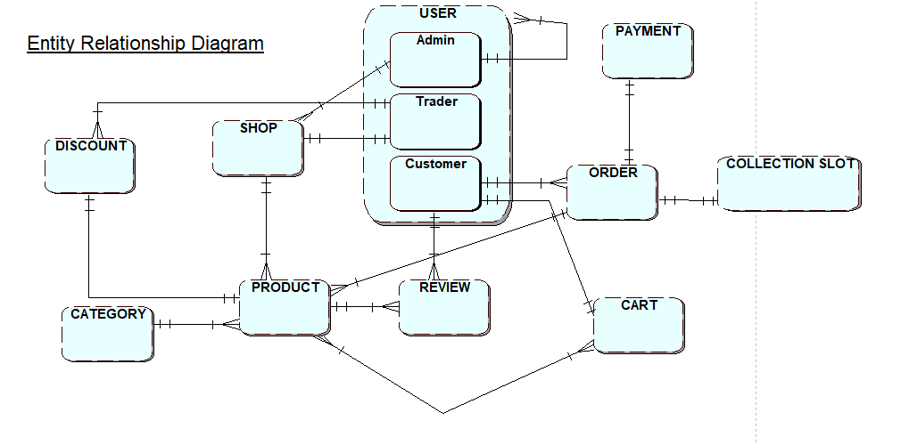

Extended Entity Relationship Diagram

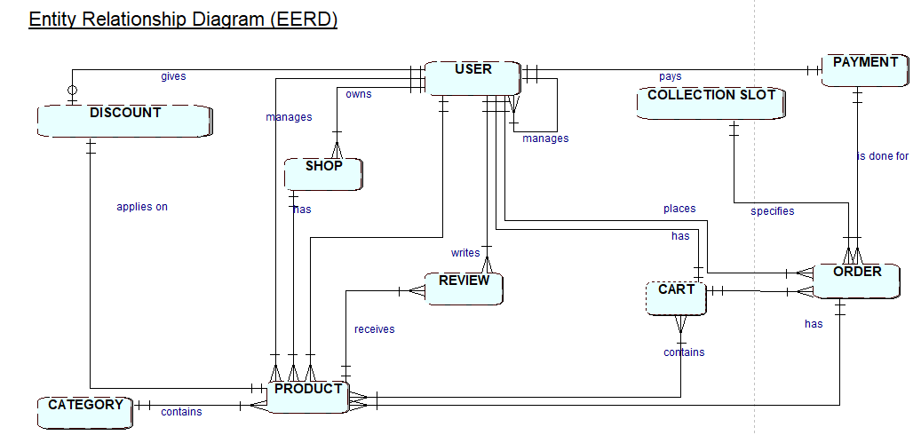

Composite Model

